Average Rainfall
Nicholas Christensen
Colorado State University Global
CSC500: Principles of Programming
Prof. Steven Evans
6/11/2026
Average Rainfall
For this assignment I selected Option 1: Average Rainfall, which uses nested loops to collect data and calculate the average rainfall over a period of years. The program first asks the user how many years to record. An outer loop then iterates once for each year, and an inner loop iterates twelve times, once for each month, prompting the user for the inches of rainfall that month. As the loops run, the program accumulates the total number of months and the total inches of rainfall, and it finishes by displaying the total months, the total rainfall, and the average rainfall per month for the entire period. The program is written in Python (version 3.14) and was developed in Visual Studio Code.
Pseudocode
START
DISPLAY "Average Rainfall Calculator"
PROMPT user for the number of years
SET total_months = 0
SET total_rainfall = 0
FOR each year from 1 TO number_of_years
DISPLAY "Year" + year
FOR each month from January TO December
PROMPT user for inches of rainfall for that month
ADD the entered rainfall to total_rainfall
ADD 1 to total_months
END FOR
END FOR
COMPUTE average_rainfall = total_rainfall / total_months
DISPLAY "Number of months:" + total_months
DISPLAY "Total inches of rainfall:" + total_rainfall
DISPLAY "Average rainfall/month:" + average_rainfall
END
Source Code
"""
CSC500 - CT5: Average Rainfall (Iteration and Selection, Week 5)
Uses nested loops to collect monthly rainfall over a number of years
and reports the total months, total inches, and average rainfall per month.
Python 3.14.5
"""

MONTHS = [
"January", "February", "March", "April", "May", "June",
"July", "August", "September", "October", "November", "December",
]

def get_number_of_years():
"""Prompt for the number of years, accepting only positive whole numbers."""
while True:
years = int(input("Enter the number of years: "))
if years > 0:
return years
print("Please enter a number greater than zero.")

def get_monthly_rainfall(year_label, month_name):
"""Prompt for one month's rainfall, accepting only non-negative numbers."""
while True:
inches = float(input(f" {year_label}, {month_name}: enter inches of rainfall: "))
if inches >= 0:
return inches
print(" Rainfall cannot be negative. Please try again.")

def main():
print("Average Rainfall Calculator")
print("---------------------------")

years = get_number_of_years()

total_months = 0
total_rainfall = 0.0

# Outer loop: one iteration per year.
for year in range(1, years + 1):
print(f"\nYear {year}")
# Inner loop: one iteration per month.
for month_name in MONTHS:
total_rainfall += get_monthly_rainfall(f"Year {year}", month_name)
total_months += 1

average_rainfall = total_rainfall / total_months

print("\nRainfall Summary")
print("----------------")
print(f"Number of months: {total_months}")
print(f"Total inches of rainfall: {total_rainfall:.2f}")
print(f"Average rainfall/month: {average_rainfall:.2f}")

if __name__ == "__main__":
main()

Screenshots
Figure 1
Average Rainfall source code in Visual Studio Code.
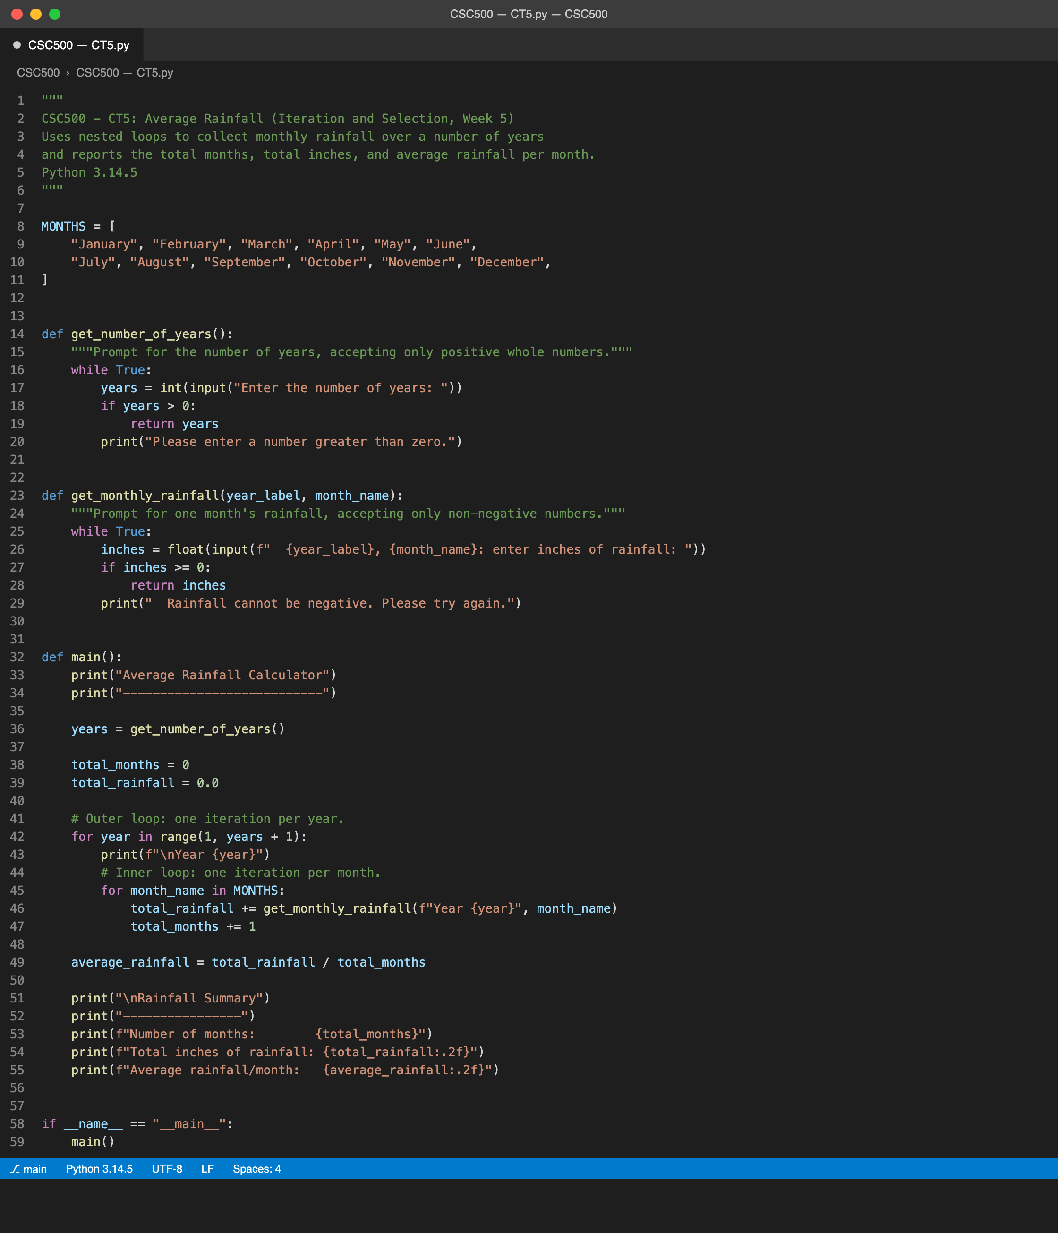

Figure 2
Program output in the terminal showing the rainfall summary.
